Property inventory
Check-in inventory Check-out inventory
Date
Tenant’s new address

Property
Apartment House
Size: Rooms:
Property description:
Address:
N° street

Landlord
Name:
Address:
and

TenanT(S)
Name:
Address:
and
Name:
Address:

Meter readings (water, gas, etc.)
TYPE | Serial number | m3 | Wear and tear | Working condition | Comments

ELECTRICITY Meter readinG
TYPE | Serial number | KW | WEAR AND TEAR | Working condition | Comments

Heating system
Type | Wear and tear | Working condition | Comments

Water heating
Production type | WEAR AND TEAR | Working condition | Comments

ROOF
Type | Description | condition | Comments
Roof
Woodwork
ISOLATION
Gutters
Downsprouts

Other interior and exterior EQUIPEMENTs
Equipement(s) | Description | Wear and tear | Working condition | Comments
Doorbell
Alarm
TV antenNa

Keys
Number of keys delivered this day:
Type | Number | Delivered this day | DATE | COMMENTs
 |  |  | 25/06/19

Property layout
For each room and for each equipment, precise the description, the wear state and its functioning.

Example: « New », « In good condition », « Working order », « Out of order ».

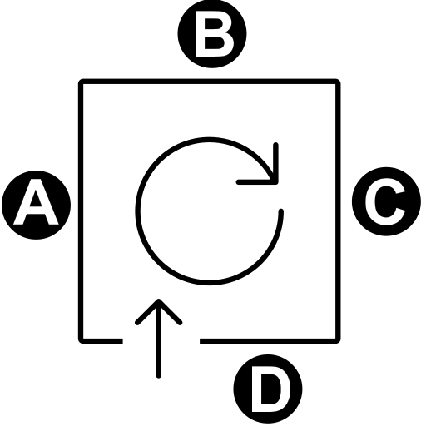
The image indicates the position of the walls (A, B, C, D).

ENTRANCE

Equipement(s) | Description | Wear and tear | Condition | Comments
Front door
Floor
SKIRTING
Wall A
Wall B
Wall C
Wall D
Ceiling
Windows(S)
Shutters, blinds
Heating
Air conditioning
Light switches
Sockets
LIGHTING

Comments on the room:

LIVING ROOM

Equipement(s) | Description | Wear and tear | Condition | Comments
door
Floor
SKIRTING
Wall A
Wall B
Wall C
Wall D
Ceiling
Windows(S)
Shutters, blinds
Heating
Air conditioning
Light switches
Sockets
LIGHTING

Comments on the room:

KITCHEN

Equipement(s) | Description | Wear and tear | Condition | Comments
Door
Floor
SKIRTING
Wall A
Wall B
Wall C
Wall D
Veiling
Lower kitchen unit
Upper kitchen unit
workplan
Sink
Sink cabinet
Ventilation
Window(S)
Shutters, Blinds
Closet
Heating
Air conditioning
Light switches
Sockets
LIGHTING

Comments on the room:

ROOM 1

Equipement(s) | Description | Wear and tear | Condition | Comments
door
Floor
SKIRTING
Wall A
Wall B
Wall C
Wall D
Ceiling
Windows(S)
Shutters, blinds
Heating
Air conditioning
Light switches
Sockets
LIGHTING

Comments on the room:

ROOM 2

Equipement(s) | Description | Wear and tear | Condition | Comments
door
Floor
SKIRTING
Wall A
Wall B
Wall C
Wall D
Ceiling
Windows(S)
Shutters, blinds
Heating
Air conditioning
Light switches
Sockets
LIGHTING

Comments on the room:

BATHROOM 1

Equipement(s) | Description | Wear and tear | Condition | Comments
Door
Floor
SKIRTING
Wall A
Wall B
Wall C
Wall D
faïence
Ceiling
Window(s)
Closet
Bathroom Sink(s)
SHower, THUB
Toilet
Toilet seat
Plumbing
Flush system
Seals
Heating
Ventilation grid
Light switches
Sockets
LIGHTING

Comments on the room:

BATHROOM 2

Equipement(s) | Description | Wear and tear | Condition | Comments
Door
Floor
Baseboard
Wall A
Wall B
Wall C
Wall D
faïence
Ceiling
Window(s)
Closet
Bathroom Sink(s)
douche, bAignoire
Toilet
Toilet seat
Plumbing
Flush system
Seals
Heating
Ventilation grid
Light switches
Sockets
LIGHTING

Comments on the room:

WC 1

Equipement(s) | Description | Wear and tear | Condition | Comments
Door
Floor
Skirting
Wall A
Wall B
Wall C
Wall D
faïence
Ceiling
Window(s)
Closet
Bathroom Sink(s)
SHOWER, THUB
Toilet
Toilet seat
Plumbing
Flush system
Seals
Heating
Ventilation grid
Light switches
Sockets
LIGHTING

Comments on the room:

NOTES

Special terms

Date , place , copies signed.

LANDLORD(S)  FULL NAME | TENANTS(S)  FULL NAME

